**TECHNICAL REPORT FOR PABLO COMPANY**

**DATA ANALYST: KIGBU ISTIFANUS**

**STUDENT ID: VEPH/20B/DA057**

**Task 16B(II)**

**Outline**

* Introduction
* Data cleaning
* Pre-analysis
* Industry type
* Stakeholder
* Value of data to the company
* Story of Data
* Pre-analysis
* In-analysis
* Data visualization and Chart
* Observation and Recommendation
* Conclusion
* References and Appendices.

**Introduction**

In today’s competitive market, understanding sales performance is crucial for sustained growth. This report presents a comprehensive analysis of Pablo Company’s sales trends, top customers, product pricing, leading dealers, and regional sales distribution. By diving deep into these key metrics, we aim to uncover valuable insights that will drive strategic decision-making.

Why does this analysis matter?

* Are our sales increasing or declining over time? Spotting trends allows us to adapt and stay ahead.
* Who are our biggest customers? Strengthening these relationships can lead to greater business opportunities.
* Which regions generate the highest revenue? Identifying top-performing zones helps refine marketing efforts and expansion strategies.
* How do transactions vary by amount? Understanding pricing dynamics ensures optimal product positioning. By answering these critical questions, this analysis provides a roadmap for improving sales efficiency, optimizing pricing, and fostering long-term customer engagement.

**Data Cleaning**

To ensure accuracy and reliability in the sales performance analysis, I sourced data from Kaggle datasets, containing key metrics such as customer details, dealer information, vehicle specifications, pricing, and regional distribution. Using Microsoft Excel, I leveraged pivot tables, statistical functions, and trend analysis tools to uncover patterns and meaningful connections within the data. The following crucial data-cleaning steps were taken to enhance consistency and precision:

* Inconsistency Removal – Standardized categorical variables to eliminate labeling discrepancies.
* Duplicate Check – Ensured no redundant entries to maintain data integrity.
* Structured Table Conversion – Transformed raw data into a dynamic Excel table for seamless analysis and automation.

With a cleaned and well-structured dataset, our analysis delivers accurate insights into sales trends, customer behavior, and market performance, setting the stage for informed decision-making.

**Pre-Analysis**

***Project Split:***

In the pre-analysis the following stages were carried out:

Data splitting: The dataset was categorized into category one and two also refer as Independent (make meaning on their own) and dependent (does not make meaning on their own) values.

Independent values from the datasets: Sales rep

* Customer name
* Gender
* Dealer Name
* Company
* Color
* Boday Style
* Dealer Region

Dependent values:

* Car Id
* Date
* Model
* Engine
* Transmission
* Price
* Phone No

This Dataset belongs to Pablo company, Pablo is a car sales company where Revenue is a key business metrics.

The stake holder of this company is the Chief executive Officer and other groups.

This analysis helps the Head of Retail operations and business development make informed decisions that boost revenue, optimize operations by evaluating salespersons performance, therefore, refining marketing efforts and enhancing customers satisfaction.

***Industry Type***

This dataset comes from Pablo Car Company, a global leader specializing in the buying and selling of a wide range of vehicles. With a presence in international markets, this dataset provides valuable insights into car transactions, market trends, and customer preferences worldwide.

***Stakeholder:***

The Stakeholder of the company is the Chief Executive Officer.

***Value of the data to the industry****:*

* **Market Demand Analysis** – Identifies the most popular car models, brands, and features, helping optimize inventory and sales strategies.
* **Pricing Optimization** – Enables dynamic pricing based on historical sales trends, seasonal demand, and regional preferences to maximize profitability.
* **Customer Insights** – Analyzes buyer demographics, preferences, and purchasing behavior to enhance marketing strategies and customer engagement.
* **Operational Efficiency** – Tracks sales performance, dealership efficiency, and supply chain logistics to streamline operations and reduce costs.

***Story Of The Data***

The dataset unfolds an insightful narrative about the diverse range of cars sold by dealers across multiple regions, capturing key aspects of the automotive market. It highlights the **quantity of vehicles sold,** the **total purchase amount,** and the **performance of different car dealers**, providing a comprehensive view of sales dynamics. Additionally, it delves into **customer preferences**, showcasing trends in **car models, colors, and purchasing patterns** across various locations. By analyzing this data, valuable insights emerge, enabling better decision-making, optimized inventory management, and tailored marketing strategies to meet the ever-evolving demands of the global car market.

***Pre-analysis***

These are the initial trend that were observed.

* Best performing region by revenue generated
* Performance analysis of each car dealer by revenue
* Customer performance analysis based on revenue
* Customer performance analysis based on purchase
* Customer performance analysis based on company
* Customer performance analysis based on car Colour
* Best performing cars for the year by quantity
* Best performing cars by revenue
* Performance analysis across the month base on revenue
* Region against quantity
* Region against Revenue

**Initial insight:**

* Fine tune the best region and to explore more measures to gain more grounds against competitors e.g. more advertisement
* fine tune the least performing region and implement measures in the best performing region and ensure the measures are kept in place by e.g. transferring dealers in the region with great sales to regions of low sales to ensure the enact measures in the best performing region
* Most used and bought model: introduce the most used car model and type in the less performing regions
* Stock in most purchased Cars so it doesn’t get exhausted

**In-analysis.**

After carrying out analysis and plotting the charts the following were observed:

* Leading car dealer is the progressive shippers with revenue generated of 1,055,204,894
* Emma is the best performing customer with the annual income of $78,304,500.
* we have found out that the month with the greatest sales is December
* The best performing region is the Austin with the revenue generation of $ 3,402,482,981.
* The best performing product of the year is Chevrolet with revenue of $47,655,265
* The Best price was at $50,000,000,

**Data Visualization And Charts**

**Dashboard**

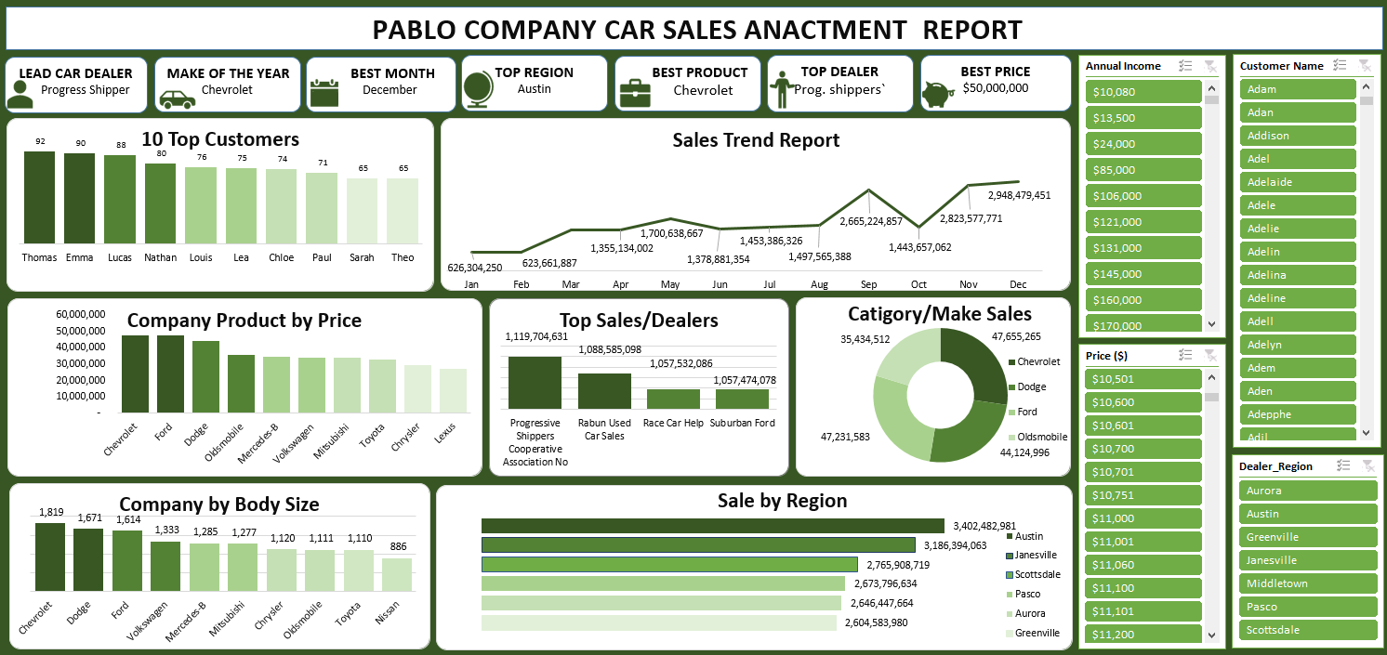

**Observations and Recommendation.**

**Observations:**

* At January the company made the least sells of 626,304,250 and Chevrolet made the best
* Sales while chryster made the least sells. on the regional aspect Janesville top the sells for the
* Month. At December Ford tops in product price while chevrolet still tops in sales per make by 18% of all the car products.
* Jan kotas is the least performing sales person thus had least sales in April/May and the best sales in June. More so had his best transactions between 0-1000 which shows that people like cheap things.
* Austin region performed the best with $3,402,482,981 revenue.
* Prices from 0-1000 brought in more turnover.

**Recommendation:**

Based on the observed sales trends and performance metrics, the following data-driven recommendations can help optimize sales strategies, improve dealer performance, and enhance overall profitability.

* Conduct a detailed market analysis to identify factors contributing to the low sales volume in January.
* Implement targeted seasonal promotions or discounts to boost demand.
* Enhance marketing efforts during this period by leveraging customer insights and offering incentives such as limited-time discounts or financing options.
* Since Chevrolet consistently tops in sales, the company should allocate more inventory to this brand.
* Utilize predictive analytics to determine the best-selling models and optimize regional stock distribution.
* Increase targeted advertising efforts for Chevrolet in regions where demand is high.
* Investigate why Chrysler had the lowest sales—was it pricing, model availability, or customer preferences?
* Implement special offers, trade-in deals, or financing options to encourage more purchases.
* Conduct customer feedback analysis to understand potential gaps in demand.
* Since Janesville led sales in January, identify the factors driving high demand and replicate those strategies in underperforming regions.
* Strengthen dealer partnerships in this area to maintain a steady supply of high-demand vehicles.
* Ford topped product pricing in December, indicating a preference for premium cars. Capitalize on this trend by promoting high-end vehicle models during the holiday season.
* Implement exclusive holiday promotions, financing options, and bundled deals to increase revenue.
* Since Jan Kotas performed poorly in April/May but improved in June, analyze what strategies contributed to the sales boost and apply them year-round.
* His best sales transactions were between $0-$1,000, indicating a demand for affordable cars. Consider launching budget-friendly marketing campaigns and expanding low-cost vehicle offerings.
* The data indicates that low-priced cars generated higher turnover, meaning affordable options attract more buyers.
* To boost sales, consider:
  + Expanding the budget-friendly car segment.
  + Introducing trade-in and financing options for cost-sensitive buyers.
  + Implementing targeted marketing campaigns for lower-cost models to reach price-conscious customers.

**Conclusion:**

By leveraging these insights, **Pablo Car Company** can improve overall sales, optimize inventory management, and enhance customer satisfaction. A data-driven approach ensures that the company maximizes revenue opportunities while adapting to changing market trends.

**Reference**

Smith, J. (2023). Global car sales dataset (Version 1.0) [Data set]. Kaggle. <https://www.kaggle>. com/datasets/ example